Text Clipping:

Several methods are available for clipping of text. Clipping method is dependent on the method of generation used for characters. A simple method is completely considered, or nothing considers method. This method is also called as all or none. If all characters of the string are inside window, then we will keep the string, if a string character is outside then whole string will be discarded in fig (a).

Another method is discarded those characters not completely inside the window. If a character overlap boundary of window. Those will be discarded in fig (b).

In fig (c) individual character is treated. Character lies on boundary is discarded as which it is outside the window.

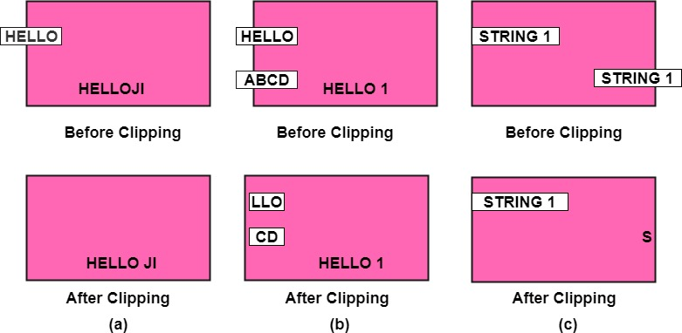

Curve Clipping:

Curve Clipping involves complex procedures as compared to line clipping. Curve clipping requires more processing than for object with linear boundaries. Consider window which is rectangular in shape. The circle is to consider against rectangle window. If circle is completely inside boundary of the window, it is considered visible. So save the circle. If a circle is in outside window, discard it. If circle cut the boundary then consider it to be clipping case.

Exterior Clipping:

It is opposite to previous clipping. Here picture which is outside the window is considered. The picture inside the rectangle window is discarded. So part of the picture outside the window is saved.

**Uses of Exterior Clipping:**

1. It is used for displaying properly the pictures which overlap each other.
2. It is used in the concept of overlapping windows.
3. It is used for designing various patterns of pictures.
4. It is used for advertising purposes.
5. It is suitable for publishing.
6. For designing and displaying of the number of maps and charts, it is also used.

Polygon Clipping:

Polygon clipping is applied to the polygons. The term polygon is used to define objects having outline of solid. These objects should maintain property and shape of polygon after clipping.